School Supplies 2025-2026 (Gr. 2)

4 whiteboard markers for use on individual whiteboards

3 pads of sticky notes (3”x3” or smaller)

5 Duotangs (red, blue, green, yellow, orange)

Hilroy Exercise books: 72 pages (5)

-1 blank pages (light blue)

-1 full interlined (dark blue)

-3 half and half interlined (green)

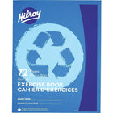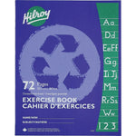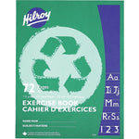

White eraser (4)

Highlighters (2)

Markers (1 pkg)

Pencils (30)

Pencil crayons (1 pkg of 24)

Pencil case/box

Red Pens (3)

Scissors

Wax crayons (1 pkg of 24)

Ruler (1)

Large glue sticks (4)

Headphones Indoor Shoes

Pencil Sharpener with Lid

Communication/Kanga Pouch- (Can be reused from past years)