School Supplies 2025-2026 (Gr. 1)

2” binder with clear overlay (1)

Duotangs (10)

Exercise books/scribblers (6)

-2 full interlined (blue)

-4 half interlined (green)

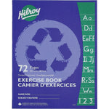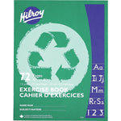

White eraser (4) - labelled

Highlighters (2) - labelled

Markers (1 pkg) - labelled

Pencils (pre-sharpened) (30) - labelled

Pencil crayons (pre-sharpened) (1 pkg of 24) - labelled

Pencil case/box (1) - labelled

Wax crayons (1 pkg of 24) - labelled

Large glue sticks (4) - labelled

Headphones – in a labelled plastic bag (1)

Indoor shoes- labelled

Communication bag/home reading pouch

Pencil sharpener with lid

Scissors

3 pads of sticky notes (3” x 3” or smaller)

4 Whiteboard Markers for use on individual whiteboards (preferably different colors)