School Supplies 2025-2026 (ECS)

2 whiteboard markers for use on individual whiteboards

1" Binder (for memory book)

Exercise books/scribblers (2) (1 blank and 1 with half inter-lined)

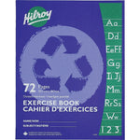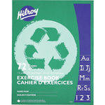

White erasers (2)

Washable markers (1 pkg)

Pencils (5)

Wax crayons (1 pkg of 24 or more)

Ruler (1)

Glue sticks (4)

Pencil case/box (1)

Scissors (1)

Headphones (1)

Indoor shoes (labelled) Velcro Preferred

Note: crayons and markers will be shared and cannot be returned at the end of the year.